SmartCare v0.3 - Domain Model Workbook
Week 6 student resource

Requirement-to-Concept Trace
Requirement | Concept | State/behaviour | Decision
FR-01 Create an appointment | Appointment | Behaviour – create appointment | Keep as class
FR-02 Store patient information | Patient | State – patient information | Keep as class
FR-03 Store practitioner information | Practitioner | State – practitioner information | Keep as class
FR-04 Associate patient and practitioner with appointment | Appointment | State – patient and practitioner | Keep as class
FR-05 Store appointment date and time | Appointment | State – date/time | Keep as attribute
FR-06 Prevent duplicate bookings | Appointment | Behaviour – check booking conflict | Keep as behaviour
FR-07 Search for patient information | Patient | Behaviour – search patient | Keep as behaviour
FR-08 Record appointment status | Appointment | State – status | Keep as attribute
FR-09 Cancel an appointment | Appointment | Behaviour – cancel appointment | Keep as behaviour
FR-10 Retain appointment history | Appointment | State – appointment/history | Keep with Appointment

CRC Cards

Patient
Responsibilities | Collaborators
Store patient information | Appointment
Provide patient details | Appointment

Practitioner
Responsibilities | Collaborators
Store practitioner information | Appointment
Provide practitioner details | Appointment

Appointment
Responsibilities | Collaborators
Store appointment date/time | Patient
Record appointment status | Practitioner

Optional class
Responsibilities | Collaborators

UML Class Diagram
Insert/draw UML here. Include defensible relationships and multiplicities.
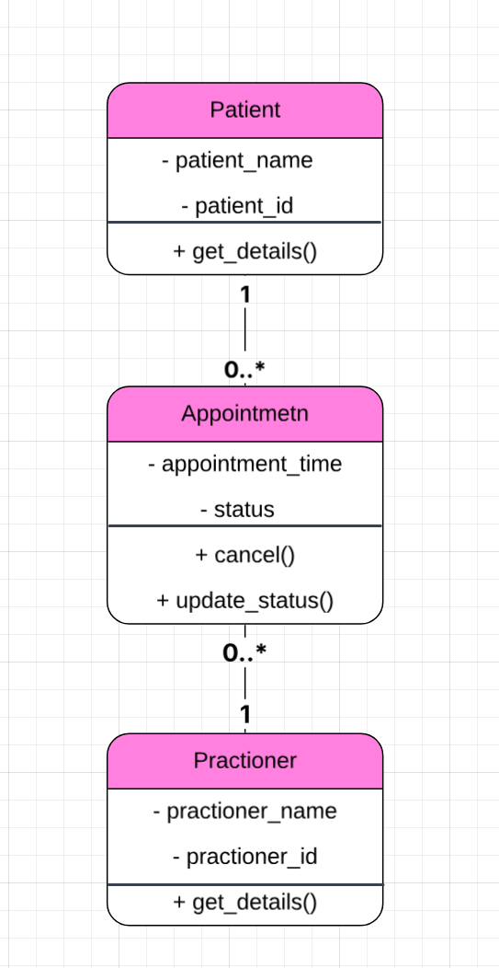

Design Rationale
Explain class selection, responsibility allocation and key relationships.
Patient, Practitioner and Appointment were chosen because they are the main concepts supported by the requirements. Appointment connects a Patient with a Practitioner and stores the appointment details. A Patient and Practitioner can each have multiple appointments.

AI Design Review Record
AI suggestion | Evidence | Decision | Reason | Model change
Use Patient, Practitioner and Appointment as the main classes | FR-01 to FR-10 | Accepted | These classes are directly supported by the confirmed requirements and match the original model. | No change needed
Store appointment history as an attribute of Appointment | FR-10 | Modified | Appointment history is better represented by retaining previous Appointment objects rather than storing history as a single attribute. | Removed history as an Appointment attribute
Add searchPatient() as a behaviour of Patient | FR-07 | Rejected | Searching across patients does not fit the responsibility of one individual Patient object. | searchPatient() was not added to Patient
Use one-to-many relationships between Patient–Appointment and Practitioner–Appointment | FR-04, FR-06, FR-10 | Accepted | A patient or practitioner can be associated with multiple appointments, while each appointment has one patient and one practitioner. | Relationships kept in final UML

